Database sign-off checklist

Organization:
Database:
Database filename:
Checked by:
Date:
Problems/Comments:

Signed off by:

Date:
Problems/Comments:

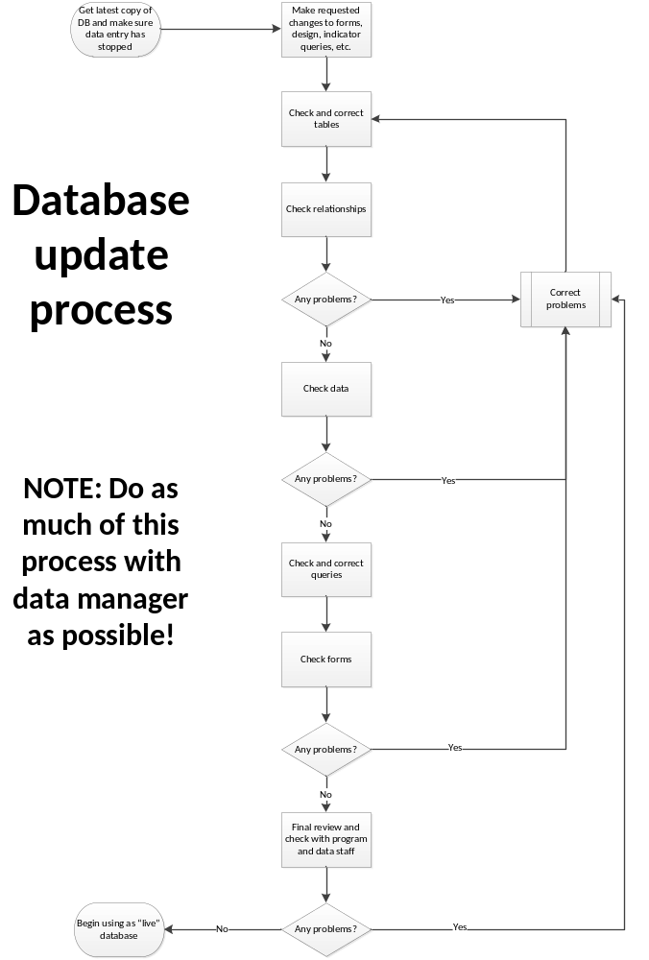Table checks
- All tables have an unique primary key? | Yes | No
- All fields have a descriptive, yet fairly short, name that uses only letters and numbers and doesn’t use reserved words? | Yes | No
- All fields have names with no spaces? | Yes | No
- All fields have the appropriate data type set? | Yes | No
- All non-text fields have validation rules that, if needed, allow dk/refused/etc. codes as well as valid input checks and validation text? | Yes | No
- All date fields have medium date format set? | Yes | No
- Field length for text should be 30 or less | Yes | No
- All fixed-length fields (e.g., 4-year date, or 2-digit areacode) have correct input masks set? | Yes | No
- All code fields (e.g., fields that use lookup boxes or codes like 1=yes, 2=no, etc.) have correct lookup settings? | Yes | No
- All code fields use the standard coding conventions? (table of conventions TBD; things like 9 = dk, 8 = refused, 7 = not at home, etc.) | Yes | No
- Lookup tables use standardized spellings and codes (e.g., tracts or area names) | Yes | No
- All fields that require data entry have required enabled? | Yes | No
- All fields with lists are limited to list and cannot add/edit list | Yes | No

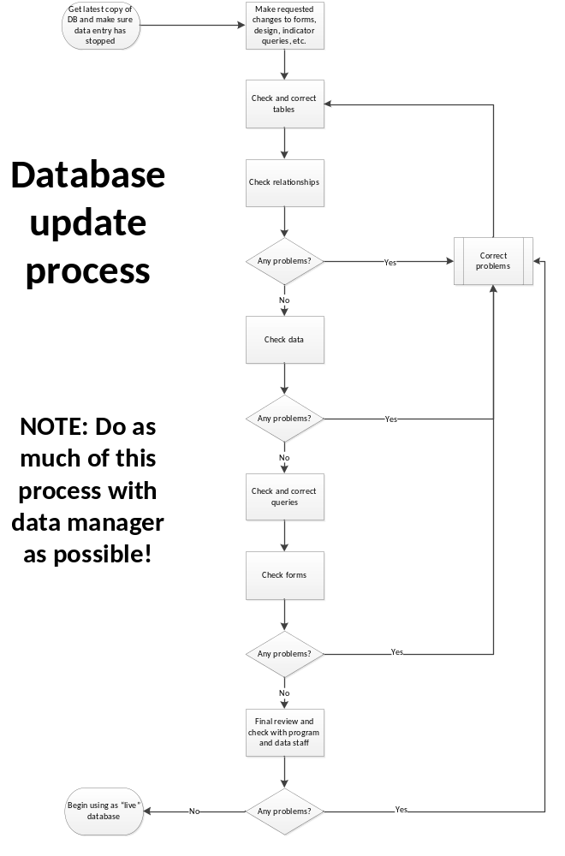

Relationship checks
- Fields that are in relationships have the same name in both tables | Yes | No
- All relationships are set up that are needed to reduce redundant data (e.g., one piece of data can be found in exactly one place in the database)? | Yes | No
- Appropriate relationships exist to link data over time (e.g., if immunization records, should have a link to a specific child so that a trend or list can be easily queried)? | Yes | No
- All relationships have enforced referential integrity and correct settings for cascade update? | Yes | No
- All relationships are between number data types? | Yes | No
- There are no unexpected “orphaned” (not linked to anyone) tables? | Yes | No
- Relationship view is not ugly - readable | Yes | No

Data checks
- Data missing, randomly changed, or improperly linked? | Yes | No
- Redundantly stored? | Yes | No
- Data passing all validation checks? | Yes | No
- Add missing values if necessary due to refactoring/normalization | Yes | No
- All lookup table data is up to date? | Yes | No

Query checks
General
- Are all queries clearly labeled? Use:  - Clean-, Validate-, Grab-, Indicator-  - -Num-, -Percent-, -Sum-, -Average-, etc. (earlier in the query)  - -subquery, -by area, -by clinic, -all areas, -old, -tofix, -todo | Yes | No
- Queries have only letters and numbers and dashes and spaces | Yes | No
- Are unnecessary queries deleted? | Yes | No
- No update or delete queries exist? | Yes | No
- Are query result fields properly labeled if needed? (e.g., don’t use expr1: - use Percentage with diarrhea: ) | Yes | No
- Parameter-based? | Yes | No
Cleaning queries
- Have you checked with program staff about common data entry errors that may need cleaning queries? | Yes | No
- (For older dbs) Do queries exist for date conversion checks? | Yes | No
- Do queries exist that cross-check dates in a form? | Yes | No
- Do queries check for invalid combinations of responses? | Yes | No
Validation queries
- Do queries exist for random pulls with an appropriate percentage? (5% to 20%, depending on amount of data entered) | Yes | No
Indicator queries
- Have you checked with program staff that the indicator list is up to date? | Yes | No
- Based on google docs indicator lists, do queries exist to calculate every indicator listed?  - Is it using the right numerator and denominator? | Yes | No
Form
Did you check that:
- All buttons work as expected (enabled or disabled, depending on implementation status and right query)? | Yes | No
- There is an organizer? | Yes | No
- All forms are based on a saved grab query (visible in the query object browser)? | Yes | No
- Lookup fields are correct for finding and opening records? | Yes | No
- Lookup field formatting for columns lets you actually read everything? | Yes | No
- Forms look as similar as possible to paper forms? | Yes | No
- When invalid data is entered in each field, it warns you and refuses to save the record? | Yes | No
- That if there is inconsistency/logic between fields, that it warns you and refuses to let you save the record? | Yes | No
- Field layout in a consistent and easy to read? | Yes | No
- Only relevant (e.g., what you looked up) records are returned? | Yes | No
- Multiple record return forms sort the data in an appropriate way on the form? | Yes | No
- Tab orders are correct? | Yes | No
- Once you enter the data in the correct input mask, it auto-advances to the next field? | Yes | No
- If a lookup box to an id field for a relationship, there is a field next to it that shows the actual (useful) text? | Yes | No
- Lookup fields that appear in headers are locked and disabled? | Yes | No
- Hidden fields are hidden, locked and disabled, and a different color from visible fields? | Yes | No
- Data entry forms are modal? | Yes | No
- Delete orphan forms? | Yes | No

Review with data and program staff
- Review the database with program and data staff, having them try to find/enter data as well as try a cleaning query and an indicator query? | Yes | No
- Review the database with program staff, checking to make sure all indicators are included and queries/assumptions are correct? | Yes | No
- Disable further design changes? | Yes | No

